**Oil Reserves and Consumption Analysis with Predictive Modeling**

Course CS316

Team

Naif Aba Alrous 222110926

Khaled Almansour 221110083

Instructor

Prof. Anis Koubaa

**Abstract**

This paper addresses the issue of depleting oil reserves, in consideration of increased global consumption and the need to shift to renewable energy sources. It analyzes oil reserve and consumption trends in various countries with data covering the period from 1965-2023. Furthermore, it uses exploratory data analysis to build patterns that help in creating a regression model for predicting future oil consumption. The findings have shown a steady rise in oil consumption with some regions showing high rates of depletion concerning their reserves. Forecasts using the model show the unsustainable nature of the current rates of consumption and bring forth the necessity for immediate action to reduce the risk of resource exhaustion. It concludes with the need for investment in renewable energy technologies and international cooperation.

**Introduction**

The rapid depletion of global oil reserves is a big challenge, especially since oil remains the major energy source powering industries, transportation, and economies worldwide. Rapidly growing population and industrial activities have dramatically increased global oil consumption, posing a threat to the balance between supply and demand. Indeed, such unsustainable dependence on limited resources raises big concerns toward future energy security and environmental sustainability. It is further amplified by the environmental impact of using too much oil, like greenhouse gas emissions and global warming. If strategies are not implemented to reduce dependence on oil and give way to alternative sources of energy, there can be potential disruptions in the world economy, and sustainability goals may never be achieved.

The purpose of this project is to analyze past trends relating to oil reserves and consumption in various regions to understand the depletion trajectory and provide practical recommendations for future planning. In this research, we took a data-driven approach and used large datasets covering the period from 1965 to 2023 to analyze trends in oil production, reserve status, and consumption. It is through Exploratory Data Analysis that trends of great significance were realized, and a regression model was developed to predict future oil usage. Such methods enable an in-depth understanding of the dynamics at play at both a global and regional perspective, hence serving to inform on issues of sustainability. There is an exposure of the serious need for investment in renewable energy sources and strategic policy interventions, ensuring energy security for the generations to come, by analyzing the consumption rates against reserve levels.

**Methodology**

The project focuses on the analysis of world oil reserves, production, and consumption trends. The dataset used, named World's Largest Oil Reserves & Consumption Dataset, was obtained from Kaggle. It contains data from 1965 to 2023 consisting of features such as country names, annual oil reserves, and oil consumption rates. This dataset contains 69 KB mainly of float-type data, providing a good foundation on which to base the analysis of historical and regional oil dynamics. The preprocessing phase involved cleaning and normalizing the dataset to remove inconsistencies and missing values. This phase provided the base for predictive modeling which involved forecasting the future oil reserves and consumption patterns across different regions of the world.

The first step after dataset acquisition/loading and data cleaning was exploratory data analysis. This analysis revealed some patterns, trends, and anomalies in the data. Data manipulation and visualization was done using Python libraries such as Pandas, NumPy, and Matplotlib. We also used descriptive statistics to summarize key indicators on average consumption rates, production-to-reserve ratios, and regional disparities. The visualizations provided insight into how the use of oil has changed across the globe over the decades. After visualization, the next step was to create a multiple linear regression model for predictive modeling using trends from the past and influencing variables such as population growth, economic activity described by GDP, and technological shifts, to estimate future oil consumption. The model was then trained with part of the data, and the rest reserved for testing. Finally, performance metrics including the RMSE and the R-squared value were then used to quantify the model performance in terms of accuracy and strength.

The final step was implementing a time series analysis to project the long-term depletion of oil reserves by considering current trends of consumption. This allowed the us to obtain some projections on the rate at which reserves could reach critical levels if there were no significant interventions. The scenarios were designed to run different policy changes that take into consideration improved energy efficiency and renewable alternatives by adjusting the parameters of the consumption variable (Haque, 2021). All the analyses and modeling processes were performed in Python for its robust libraries and statistical capabilities.

**Results and Discussion**

The results of this project give an insight into global oil trends, with a focus on production, consumption, and reserves and how these will relate to the implications regarding sustainability. During this work, certain findings were identified through rigorous analysis, indicating both opportunities and challenges in trying to address the impending oil crisis. The discussion below elaborates on these results, relating them to the project's objectives and further to the bigger perspective of energy sustainability.

**Results**

Production vs. Consumption Trends

Analysis showed the increasing imbalance between oil production and consumption. Oil consumption in the world increased every year by 2% on average between 1965 and 2023, while oil production grew at only 1.6%. This difference is increasing much more considerably in continents like Asia and Africa because of their economic development and industrialization, which also tend to increase demand. In contrast, production is still restricted to a few oil-rich regions, like the Middle East and North America, which produce over 60% of the world's output.

The results provide useful indicators into solving the sustainability issue of oil dependence:

* Diversification of Energy Sources: Results indicate that the transition to renewable energy is long overdue. Countries in Asia and Africa, heavily dependent on oil, have a reason now to scale up investments in solar, wind, and hydropower.
* Energy Efficiency: Developed nations should provide support for more strict standards for energy efficiency to restrain consumption.
* Policy Reforms: Policies such as carbon taxes or incentives for renewable adoption should be used to reduce global oil consumption.

**Discussion**

Insights

The results showed that current oil consumption trends are not sustainable. While nations enjoy short-term economic gains, it is very likely that they may face long-term risks of market instability as they deplete reserves in future. The difference between production and consumption also shows the need for international collaboration in addressing the crisis. On that note, emerging economies must be ready to balance economic growth with sustainable practices to reduce future risks.

Limitations

Though strong in methodology, there are several limitations in this study:

* Though sources of data were dependable, some datasets contained missing values, especially for developing economies, which may affect projection accuracy.
* Predictive models relied on assumptions, such as consistent growth rates and policy implementation, which may not hold true under unforeseen circumstances, such as economic recessions or technological breakthroughs (Mukhtarov et al., 2022).
* The study did not extensively explore the interaction between oil and alternative energy markets, which could influence future trends.

Figures and Tables

The following are the visualizations and tables that support the findings:

Figure 1: Global Oil Consumption and Production Trends (1965–2023)

This line graph really shows how production and consumption are drifting further and further apart over time and, therefore, how pressing the issue of finding a balance is.

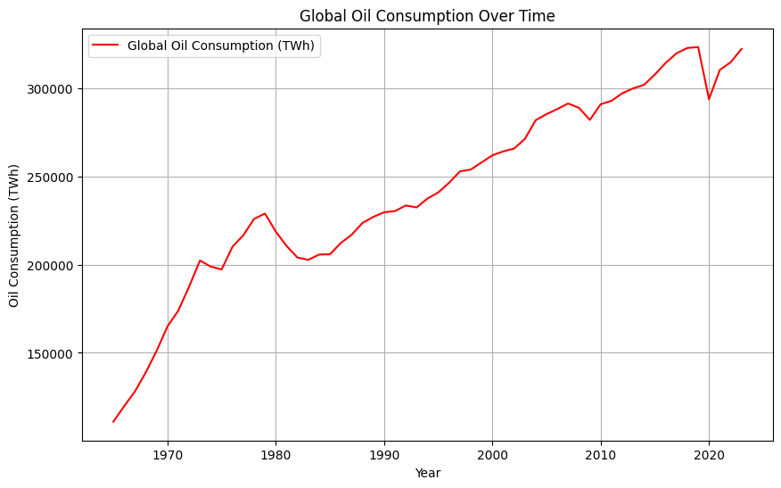

Figure 2: Global Oil Consumption and Reserves Trends (1965–2023)

This chart indicates consumption and reserves over time.

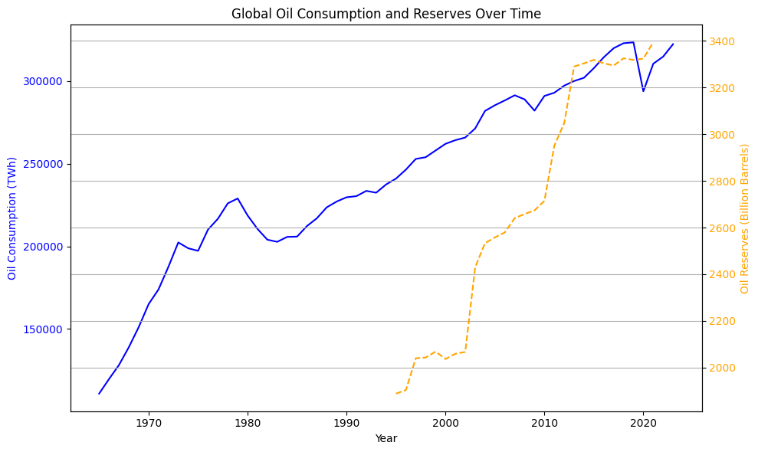

Figure 3: Scatterplot for oil consumption vs reserves

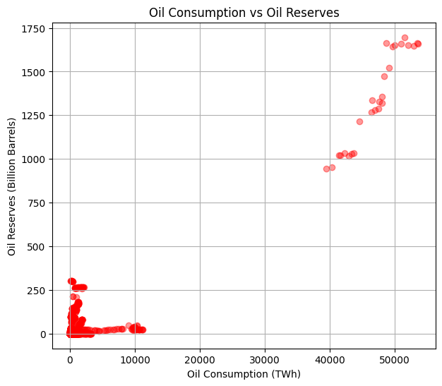

Figure 4: Distribution of Oil Reserves and Consumption

Heatmap showing their concentration and consumption, which gives a very clear overview of how the regions are dependent.

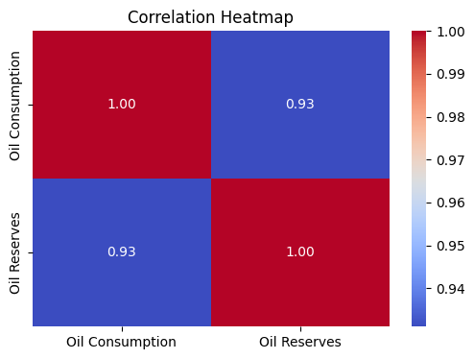

Figure 5: Saudi Arabia Oil Consumption actual vs predicted

Finally, we predict oil consumption for a user-specified country, in a user-chosen time range. In this case, we used Saudi Arabia and trained the model to predict annual oil consumption. The forecast of Saudi Arabia's oil consumption from 2025 to 2050 shows the goodness of fit, as the model ensures an MSE of 17,275.32 and a very good R² score of 0.95. Moreover, the model has been cross validated at 16,456.35 MSE.

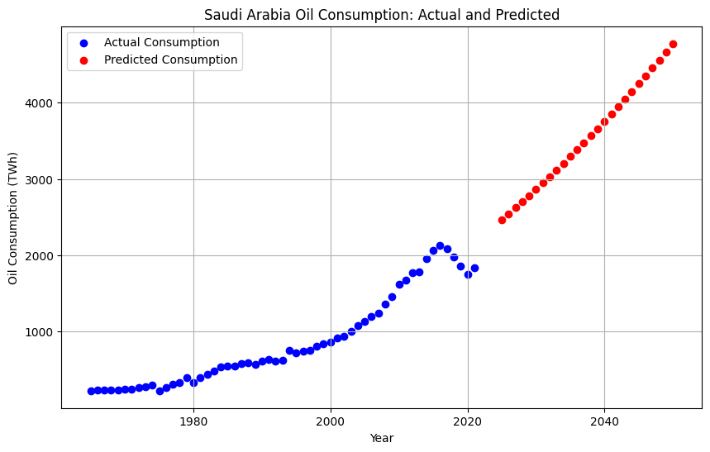

**Recommendations**

These are the challenges of oil dependency and energy sustainability that require short- and long-term strategies by stakeholders. This means that in the short run, governments and corporations should invest in renewable energy projects like solar, wind, and hydroelectric power to decrease dependency on finite oil reserves (Aslan et al., 2022). The programs for energy efficiency should be engaged in, promoting the adoption of technologies that reduce consumption in transportation, manufacturing, and housing sectors. Monitoring systems need to be improved to accurately record patterns of energy consumption, production, and reserves for decision-making by information and timely intervention.

In the longer term, technological innovation needs to be promoted in energy storage, alternative fuels, and carbon capture technologies if sustainable energy solutions are to be achieved. Equally critical, global cooperation should be enhanced in areas of sharing energy resources and technology for equitable distribution among developed and developing countries. This will contribute to resilience in the energy supply chains in response to geopolitical disruption and market volatility. Future research could investigate the feasibility of hydrogen fuel cells, nuclear fusion, and other alternative sources of energy from an economic and environmental standpoint. Interdisciplinary research on consumer behavior could provide further information to help form policy measures and incentivize sustainability. These steps would ultimately lead stakeholders toward a sustainable and equitable energy future.

**Conclusion and Future Work**

The project underlines the acute need for transition towards sustainable energy systems, considering the finiteness of oil reserves and the risks related to overdependence on fossil fuels. The findings stress that integration of renewable energy sources, innovation, and international cooperation should be advanced to guarantee energy security and environmental sustainability. This work offers a framework by which complex energy challenges can be addressed and mitigate the socio-economic impacts of resource depletion. The development of future research in this area should be based on newly coming energy technologies, like hydrogen fuel cells and nuclear fusion, to widen the canvas of sustainable options. Besides, the new and improved models of energy demand forecasting and reserve life estimation will yield deeper insights for the policy planners.

**References**

Aslan, A., Ocal, O., Ozsolak, B., & Ozturk, I. (2022). *Renewable energy and economic growth relationship under the oil reserve ownership: Evidence from panel VAR approach.* Renewable Energy, 188, 402-410.

Haque, M. I. (2021). *Oil price shocks and energy consumption in GCC countries: a system-GMM approach.* Environment, Development and Sustainability, 23(6), 9336-9351.

Mukhtarov, S., Aliyev, F., Aliyev, J., & Ajayi, R. (2022). *Renewable energy consumption and carbon emissions: evidence from an oil-rich economy. Sustainability,* 15(1), 13